**Singing Summit Evaluation 2025**

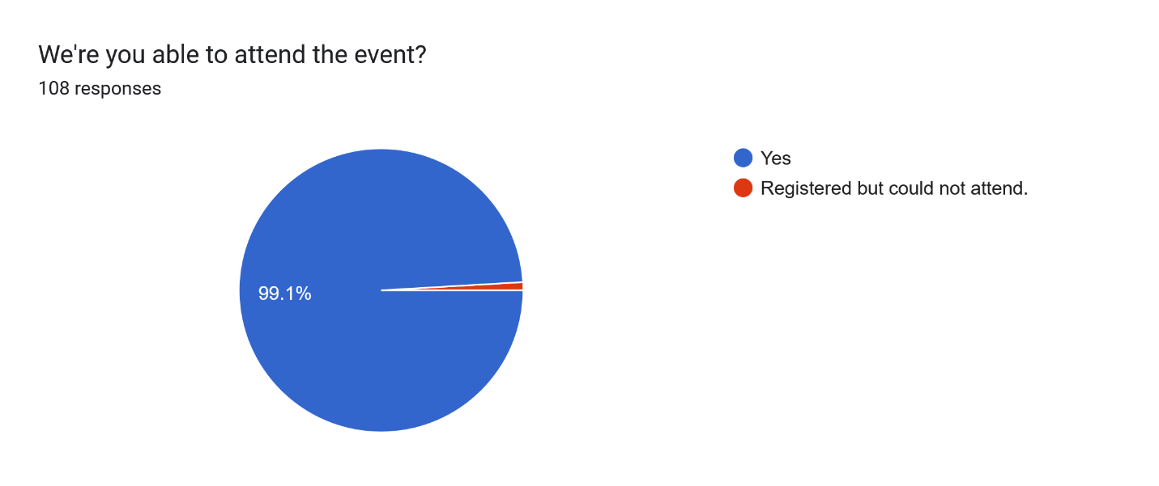

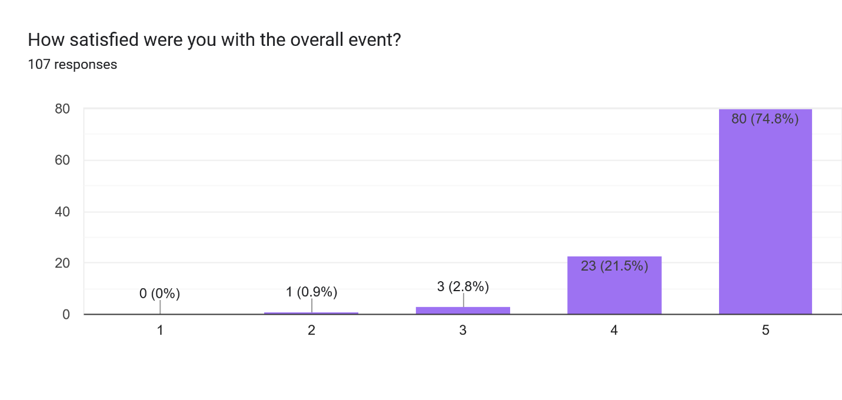

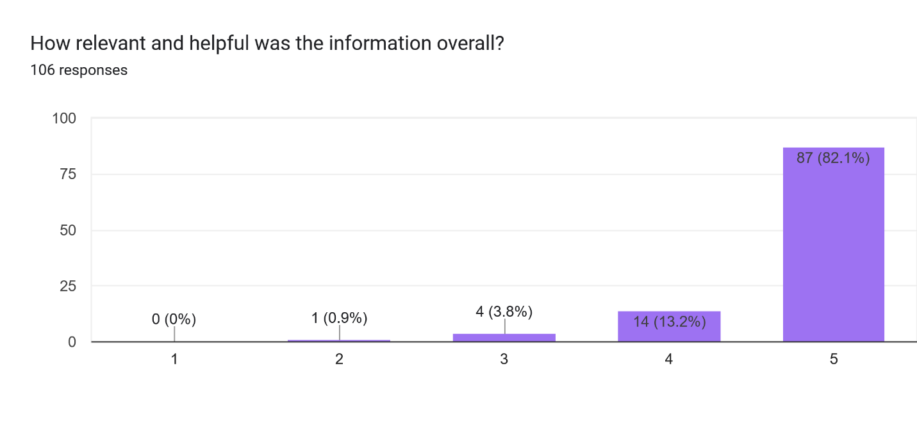

What were your key take a ways from this event?88 responses

Hiatus like in uh-oh

Too much to write about!

1) Uh-oh. 2) Bubbling then singing brings on the Air Force! 3) Throwing your sound around the room like a super power.

Loved the focus on musicality! Lori did a phenomenal job!

Great examples of communicating and miscommunicating the words and meanings of our songs. Good reminders of our breathing and the importance of our brain in producing the best sound - wide, tall, directed

Breathing information

Any education other than vocal production seems to be aimed specifically at competing choruses. And there seemed to be remarkably little singing for an event called Singing Summit.

Some great tools to help chorus sing more consistently.

Some great ways to improve my breathing for singing and the sound of communication through our music to connect with the audience and bring the best artistry we can as sweet Adeline’s to our performances.

Clarity of sound. Prosody, hiatus, importance of proper word sounds.

Lori is such an accomplished educator!

Learning beneficial tips and tricks for overall improved personal and group sound quality. As a newer member, learning the structure of barbershop competitions and the musicality tools for how chorus music is developed were useful. Being around the barbershop community was uplifting.

a lot of information and tips on musicality. mout position (goalposts and open book). prosody.

To many to mention

pay attention to the words, sing the words with intent

Everything she said....

Loved seeing the groups and loved performing

great insights into the "musicianship versus musicality" question and tools.

Vocal technique and demonstration exercises to show how it improves musicality. The session how being an SAI member has changed my life. Friday nights session about trouble consonants

sessions re: using "singing" diction to form words of song for audience understanding, allowing pauses to occur in song, demonstration re: singing full rather than loud

Using the language of the song as a communication tool.

Lori was an amazing teacher, one of the best I’ve had. It’s shocking what she is able to produce from our preformance

Breathing is everything to singing!

Ways to help improve our chorus musically, not just musicianship skills improvements.

Singing/projection improvement

Self awareness of projection techniques

Lori is an excellent coach and a phenomenal educator

The membership class was an excellent discussion of ideas for recruitment and retaining. Our director uses many of the techniques that Lori spoke about and that was encouraging. Seeing the smaller chorus's on stage was encouraging as we have lost some of our members.

Lori Lyford coaching was the most valuable to me. We were immediately able to apply the coaching to the music we are prepping for regional/international with immediate, discernable positive difference.

Wonderful educational experience. Learning more about vocal production. In addition, the Leadership class was great - would have liked to have had more time.

Breathing correctly and singing space, singing in speaking style.

clear communication with the audience

Where there are commas in the music, sing it like that with feeling. Tell the story.

Coal production and expression

Lori Lyford gave us SO much - her breathing skills class was helpful...a different way to do it!

breathing techniques, singing w clarity

Continue to learn and practice every day.

Lori's class on musicality

New ideas for getting new members and retaining old ones.

Vocal classes with Lori Lyford

Loved focus on lyrics/words and how to make them impactful

Semplico.

See my comments at the end

Being able to connect with your region in person is beneficial, even when it is hard to make the travel. Enjoyed the sing it and mean it class, probably got the most out of that class. Amy Leacock's class with the Asst. directors, directors, section leaders was great. She is a wonderful teacher and I would love more classes done by her. Not only was her energy great, she explained things in a way that I think anyone can relate and find helpful. Breathing is still my nemesis--the more we discuss/learn the more I get in my head about it and there I am back to figuring out what I need to do, when really I just need to get out of my own way. Having the lunch worked out pretty good, wasn't my favorite of choices but you can't please everyone. The show as great! I loved seeing everyone perform outside of contest. I appreciate all of the hard work that goes into making these events happen.

Goal post and relaxing jaw movement

there are small details that can make a big impact in performance!

Breath control when singing

Lengthening of vowels before adding consonants and directing your sound

Lori Lyford is one of the BEST speakers I've ever heard at one of these events!

Everything

Connection to audience/go beyond technique

Many wonderful nuggets from Lori- she was fabulous. The no need to open mouth more than to you take a surprise breath, sing between fingers/// the breathing!!

Thinking about what comes next in the song and preparing for it. Connecting with the song.

All of Lori’s classes were relevant. Learning old concepts in different and exciting ways.

The changes that have evolved regarding healthy singing over the 36 years I have been in this organization. Learning continues !

That once again we seem to be singing in the "wrong" way, like we shouldn't run words together, etc. I've been in S.A. a LONG time, so we've changed many times! ugh.

How punctuation drives dynamics and should not be ignored. How not finishing words changes the effectiveness of the song lyrics. How members of varying experience levels should work on skills differently.

Reading the lyrics and singing as if you are in a conversation.

Enjoy what you do. Know what the lyrics are trying to convey.

Moving the sound, past the director. Speak sing and breathing in the dome

Arranging music workshop was interesting and impactful; love the comradery amongst the girls who all love to sing.

When to stop at the end of a phrase if not carrying over

There is much to learn and improve in competition. There is A LOT of energy among SA women!

Lori's coaching of my chorus and her program for the directors.

"Ejecting" (poor word choice, I think) our sound--all the various "ways" and "spaces"

Sound delivery

Breathing technique and information on Regionals

Learned a lot about breath control and enunciation

Motivation to work harder to be a better singer

I feel that I enhanced my breathing techniques and got some great pointers on interpretation and diction. I liked the idea of researching the original reason the song was written. I liked the idea of the intent of the line and to whom am I singing.

All of the coaching things that Lori brought to the table. Really appreciated the real life application of all the concepts for choruses and quartets.

Pay attention to the words (prosody) in the song. Be sure you really understand the meaning/intent of the song. Learn more about the background of a song to understand the meaning. Pay attention to the commas and how they impact the meaning of phrases.

A few new tidbits of knowledge to add to my toolbox. The show was so good to watch and to perform in. The coaching was invaluable and too short! I know 2 hours for Lori is a lot after Friday and Saturday, and a lot for members who have given up their weekend, but I hated for it to end! Thanks so very much.

New to me/better ways to approach vocal production and administrative tips

It was nice to spend a weekend with friends and I am reminded, as I always am, when we get together at a regional event how cool it is to be a part of this, and that there are so many out there that just love to sing! Lori was a wonderful speaker and although I thought a lot of what she said were things I have been taught before she made it fresh with her humor. The examples she brought made the ideas easy to understand. I feel like the one thing that stood out to me was her discussion about filling our entire space with sound. It is just not sending it out in front but to the sides and up as well, and meeting and including the sounds of those around us to make a more united and singular sound. She also talked more about singing the lyric and using the emotion of the phrase to help to drive our dynamics which I love! I was glad to spend time with friends and glad for the experience!

Most anything Lori said!

Great reminder for breathing and directing techniques

Lori Lyford is a great teacher, singer and coach!

I learned a lot about breathing and annunciation.

Breathing technique, directional singing, prosody

Lori's classes were current, relevant, and on point. I also enjoyed the membership roundtable.

Diction is important to convey the message of the music

Loved the topics covered by Lori Lyford. I learned so much from her regarding breathing, musicality, communicating, vocal production. She was a hoot, kept us laughing. Time flew by quickly!

Breath support, and how to emote the music

Several ways to present a more resonant, emotional performance.

Breathing techniques and time with friends.

The Breathing to Sing lesson was awesome. Also the exercise we did with singing with the expanded sound of the box, the dome and the cone.

Great tools for singing with freedom and breathing effectively

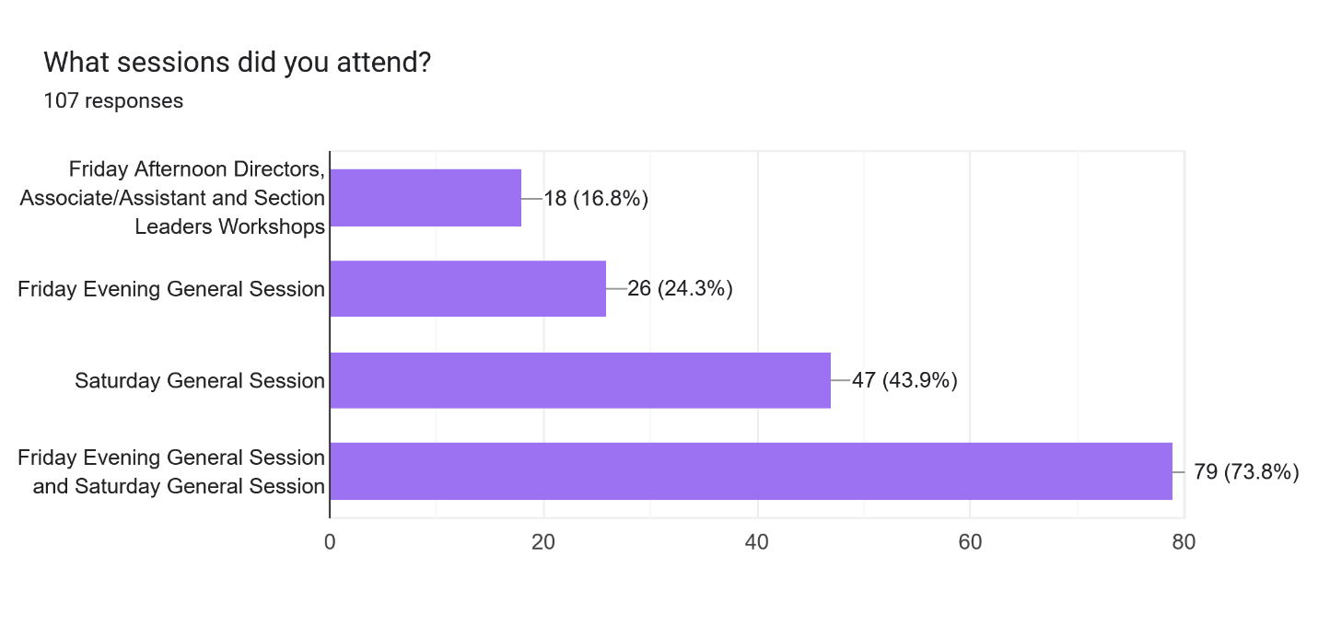

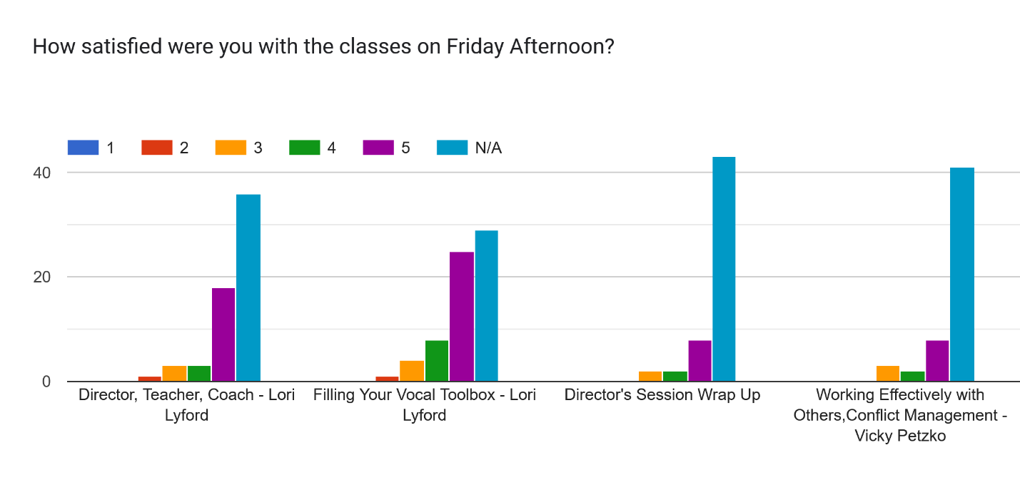

What training would you like us to provide for Directors, Associate/Assistant Directors and Section Leaders? Please be detailed.24 responses

You did it, coaching a chorus! It was great!

Have guest faculty again at future sessions. Great to have outside the region opportunities to learn.

The Alexander Technique as it applies to singing

how to clearly communicate what you want when directing

You are doing great....

Thought it was good

na

Coaching for section leaders

NA

n/a

How to get all on board

Continue what you are doing

More on how to relate to our section. Tips on How to teach our section what we learn.

How to help singers be able to distinguish wrong notes she may be singing, ie. how to improve listening/ matching skills.

Please teach us to better and more effectively use technology and social media for recruitment and retention. Include statistics on successes if you have them.

More of the same--technique especially.

I always appreciate classes that elude to real application. Perhaps a rehearse method class. A class for Section Leaders on effective sectionals. I like having a Director only class and offer a section leaders/assistant director class. I think it would be helpful to separate them out because the issues are different.

I could not get there that early on Friday, but wish I could have.

..

Lori’s classes were just what I needed!

I am a fairly new section leader and I would love some training and tips on leading a productive section rehearsal. It can be very easy to run through a song a couple times and say “okay cool we got it” but I really feel a section rehearsal can be more than that.

Every opportunity to talk to international faculty is helpful

Choral directing lessons for section leaders

Section leaders - how to help the individual members in each section - how to give a mini pvi?? Something like that.

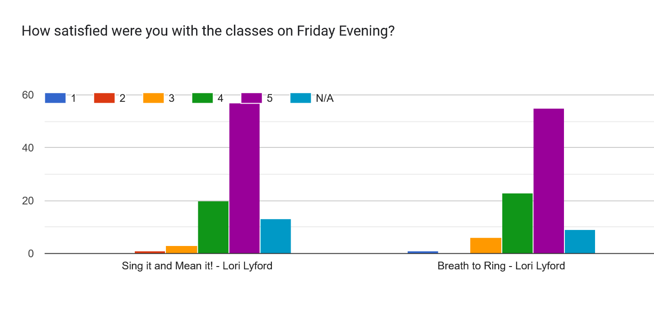\

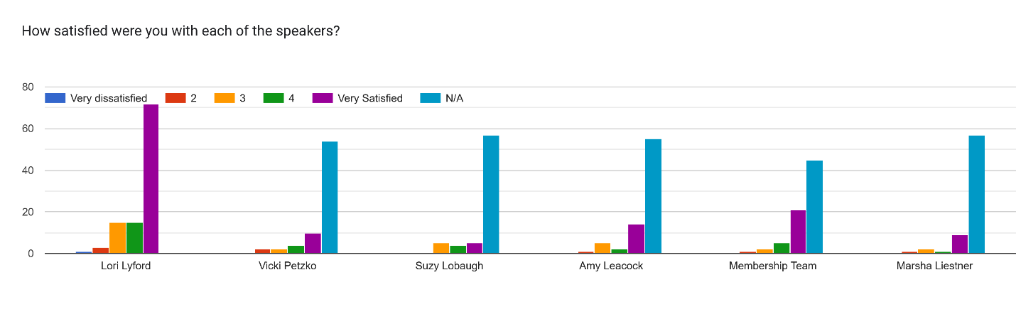

Any additional comments regarding the sessions or overall agenda?45 responses

Loved the demonstrations that Lori was able to give

The biggest issue that I know that has been brought up many times before is the sound system in the large room. Not sure if it is because of our own equipment that is used or the equipment of the hotel. For those with hearing aids, the clarity of the sound is lacking and therefore hard to hear and understand the speakers. It detracts greatly from the effectiveness of the sessions.

Loved having the variety. Lori was the perfect faculty because of her breadth of knowledge.

It was a very well organized event with great information taught throughout the weekend’s sessions.

Lori did an amazing job bringing technique and artistry approachable at all levels.

Please have more collective singing and invite the B+/A- level Open Division choruses to perform on the Saturday evening show.

i liked the overall agenda and learned a lot

A lot of Lori's presentation was reading powerpoints at us. It would be great to get away from this and have more interactive sessions.

Nope

I wonder if they could offset the rows of chairs.... it was hard to see without swinging back forth.

Is it possible to have availability to wheelchairs or scooters as the long walk iwas a hardship for some members?

venue was great, very well organized, Lori was wonderful

I was a bit disappointed with the Asst Directors & Section Leaders breakout because it didn't feel like any truly helpful information or advice was given. The handout provided had good info to use but the Q&A/ discussion part of the class didn't really provide recommendations to make us better ADs or SLs to help our chorus members better musicians so that we could concentrate on helping our director achieve increased musically for the entire chorus performances.

Everything was wonderful. Thank you all for putting together a great weekend.

I was only able to attend 1/2 day Saturday and Sunday---this time of year is difficult, but I have no better suggestion for an alternative. It is always a sacrifice to attend these events.

Would have liked to have seen the breakout sessions offered more than once - there were two classes I would have liked to have attended but I cannot clone myself - yet.

Great classes

As usual, Natalie and team handled everything well. Thank you.

Very well planned and executed! Well done team!🤗

I ended our time together with profound disappointment. The Saturday night show was the highlight. 1. We are at a SINGING summit and the only singing was done by quartets and choruses that placed during contest or those going to international. How did that involve everyone ? How was this beneficial ? 2. With regard to the classes, none were for the average member. Many of us sat in the restaurant and talked. Something we could have done at home . 3. Lori’s classes were mostly geared toward choruses focused on competing, so it seemed. Her behavior at times bordered on bullying, yelling at people, calling out the buffalo plaid person, talked about discipline in chorus but at the same time, sing from heart , life happens and have fun.. double talk 4. Where is the camaraderie ? How are building relationships with other choruses happening ? Why do I ask? The region seems like it is going out of its way to separate us… competing verses non competing choruses. What is the real goal/ focus of the Singing Summit? 1.5 days of classes that could have taken place via zoom . If more singing were taking place, you might have more attendees. I have talked with many others who share my sentiment. This was not fun. Not sure I would attend again.

For the section leader session: It would have been helpful to have an overarching review of how to structure and set up a sectional for members

My only comment is having Lori go through PDF's available on the website seems to be a waste of her time and talent.

Excellent sessions with Lori. I believe that an Open Division Chorus should be represented at the Show of Champions. They work hard to perform for the audience and attend the Summit & Chaos. It is a snub to ignore their work to perform their best.

I could not hear well due to HVAC blower and speaker mic volume. I was not comfortably warm either and so I chose to leave early. It was particularly cold in the hallway during lunch.

I couldn’t see the number 5 loved lori lyford

no

Wheelchairs and/or scooters need to be made available for those who need the extra help. It seemed to be very stress for those who had to walk the long distances. I am sure that help would have been appreciated.

My roommate & I printed off the schedule from Region #4. We had TWO different schedules! How did that happen? I needlessly printed off the songs, not realizing that was for a class I wouldn't be going to. Never did see the option to print out the actual stuff that Lori had on the big board. Speaking of, it was hard to read. Esp. on Friday night, we sat toward the back & there was a loud noise (heat or?) so couldn't hear very well. I liked it when Lori got up on the top riser to speak so you could see her better. I didn't get too much out of Lori's sessions, but I wasn't feeling too well, so that might have been one reason. I was also surprised to hear Lori tell us things that we've been doing (like using zzzs, combining one word with the next, etc. wasn't the way we should do it any more. I did like the break-out about retaining members, etc. It was nice to sit with a mix of different chorus folks. I LOVED the show--all sang SO WELL! It would've been nice to have a little printed schedule of who was singing when! Capital City didn't know when we would be singing! I'm sort of surprised with high costs, etc. that Regional #4 hasn't decided to go with just one educational meeting per year (preferably not in the winter!). I really think one meeting a year would be plenty. Sorry I got a little carried away with the above!

Great job!

A fun breakout Saturday would have been a good addition: tag singing with XYZ director.

Very efficient and well organized!!! Did not get to attend all sessions available, but certainly enjoyed and learned from the ones I atttended

Great weekend! The blower in the main room was way too loud but I doubt you can do anything about that.

There's a lot of information shared in a relatively short period of time but honestly, I don't have any idea how to do it any better (except to add another day which creates it's own problems; mostly requiring more time commitment and expense which in turn would prevent a lot of people from attending). You've done a great job!

I felt like some of the breathing info was antiquated and seems to always be done at every education session.

Lori is a delightful presenter. Attending her classes was fun and I learned a lot.

All were great and relevant.

No

Very well paced, and the show was amazing! Short enough to allow for after parties.

I liked having breaks in between.

I liked the breakout rooms a lot. It allows everyone to choose something that they more interested in learning more about in a smaller group. It also is a good way to “compare notes” My chorus had people in each breakout and that gave us an opportunity to share what learned and learn from each other

They were all FABULOUS!!! The only thing I would say is that the Saturday evening sessions we were losing interest because those were long session to be back to back. One session only or a longer break in between would be helpful :)

Great event! Loved it. Thanks for all your hard work. We appreciate it.

It was a great and very productive weekend

This was an awesome weekend and so well attended. Everything seemed to run relatively smoothly. Kudos to all who helped plan and bring this even to fruition!

Open classes with regional songs. Members want to sing, plus it would reinforce the regional songs we have. People don't know them cause we rarely sing them.

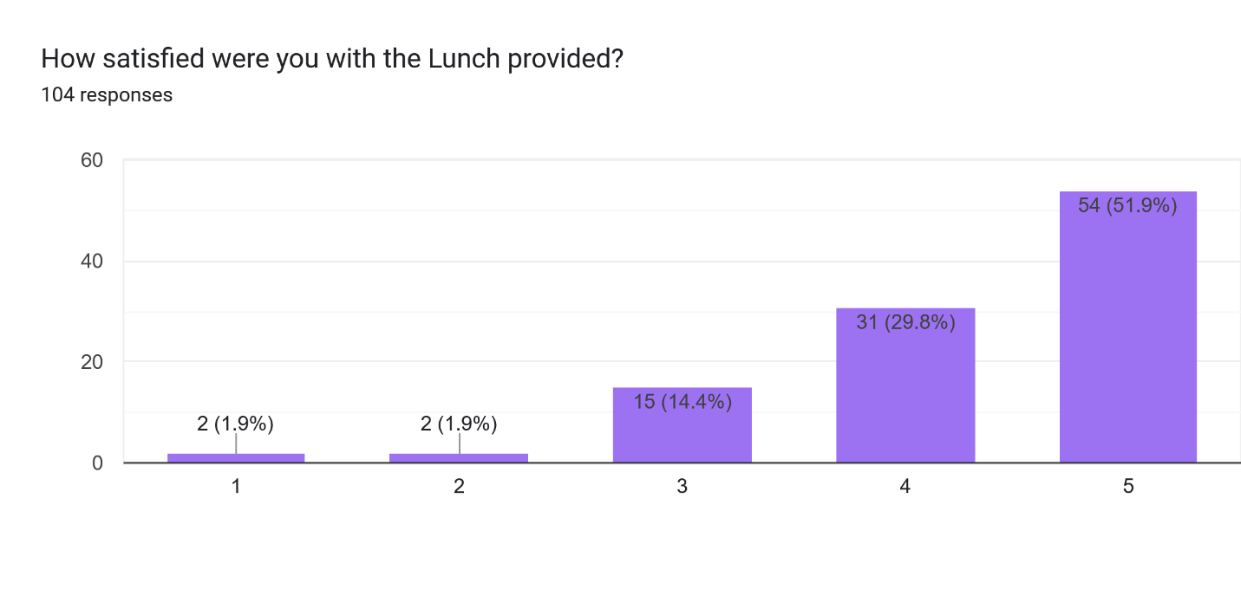

What options would you like for lunch? 64 responses

Something hot

It was fine

Salad option with protein like salmon

They were all good

I got the sweet potato wrap. It was just a little too spicy, but the sauce was only at the top. I ate it from the other end and it was terrific!

I appreciate the attention to detail for those of us with food allergies! There was also plenty of food given! It was so easy to get our meals and then be able to sit with others quickly and efficiently!! Well done!!

I don't know, but I was a little appalled at how much food was thrown away

Choices were fine.

I’m never a big fan of all the sandwiches and salads type meals. Instead I prefer burgers with gluten free buns or no buns(with fries if gluten free), bowl of fast food chili or grilled chicken nuggets or grilled chicken sandwich from chick fil a.

Lunch is the same year over year. It would be nice to have some variety. Thanks.

They were all good!

N/A

i thought selections were fine and uncomplicated

Nothing further

some veggies with the sandwich - carrots, celery

Loved the chef salad plate. And it was excellent. Do that salad again.

couldn't do it any better than you did, can't feed that many people in such a short period of timeeed that many people in such short bit of time,

I wouldn't say no to additional sandwich options!

The selections were good

Sandwiches, Wraps, Salads, Soups

Because it was a cold day, a warm/ hot option would have been nice. Something like soup or a baked potato with toppings.

Hot soup would be nice in winter. Chef salad excellent - no need for chips and potato salad.

Turkey and or ham

I loved the wrap, keep the healthy choices.

Something Hot

box lunches from Panera. My lunch was stale.

Other sandwich options offered along with soup.

More gf options

chef salad

You do the best you can. Hotel requirements are a pain, and I know the costs are terrible.

the options were fine

sandwich, salad

All was fine.

More fresh buffet of sandwich building things...... not premade☹️

No apple

Fruit as a side offering instead of chips or a cookie. non dairy options.

I like the ability to build my own sandwich or salad. There are just some things you can't take off that won't leave a trace that it was there.

soup?

Roast Beef sandwich, soup or other hot menu item

Something warm or at least a hot drink/coffee/tea

No potato salad

Other sandwich choices

None

Great options

I liked the Cobb Salad and extras.

The lunches are pretty good, but LOTS of food! I would love to have a soft drink offered as well as water. It's probably too expensive, but it would be great to have a BUFFET with a hot dish(es) along with salad.

Those were good

I like the options but always open to more. Mexican maybe?

Something hot, choice of drink

What you offered.

I had the salad so I would rather have had 2 cookies and no Cheetos. Sliced apples would have been easier to eat.

Larger variety

Food

What was offered was good.

Maybe a tangerine instead of an apple.

Choices were fine. Foodwas what I expected. generous portions

I think the options provided were great. Th vegetarian meal was delicious.

I’m not picky

These were fine

Soup

Chicken salad sandwiches and pasta salad

a hot lunch option? More gluten free options

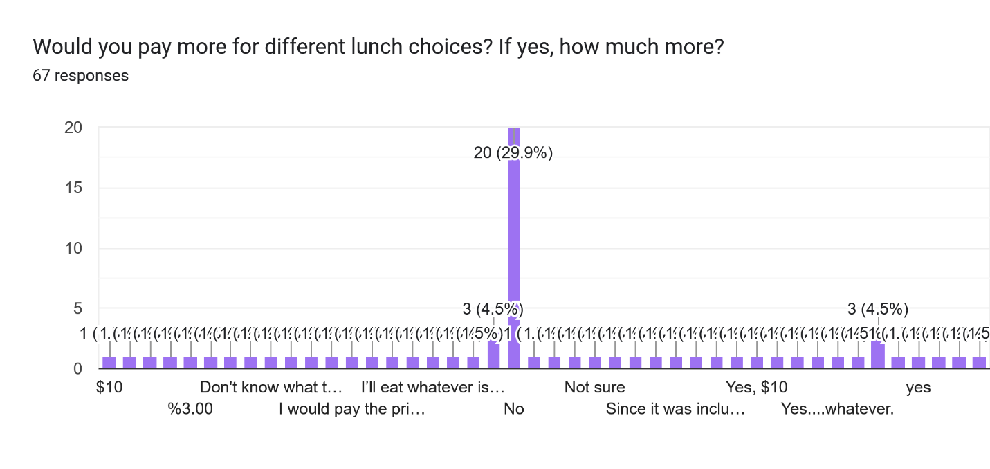

If you stayed at the hotel, how was your room?97 responses

Great

Fine

Good

Excellent

Very nice

Wonderful

Great!

Great

N/A

fine

Excellent

My room was great! No issues

Lovely

Room was a little cold but great otherwise!

Okay

excellent

A typical hotel room

satisfactory

great, very clean * comfortable bed/pillows

Clean, easy check in and out

Very good, love having everything in one hotel!

I didn't have any issues with my room, it was a very nice size with everythingIneededfor my stay. The bed pillows weren't my favorite kind but they were terrible.

excellent. Why hotels put night lights in bathrooms?

Very good

Room was excellent.

Awesome

great

Ver nice

$175?

quiet and clean

great - love Marriott, but wish the rate wasn't quite so high

It was very good

good

Like a good hotel room. No complaints.

Bathroom door did not close on Friday. It was fixed on Saturday.

Room was good

Well maintained

Fabulous

Room was fine.

fine - nice to not have to drive anywhere during the day to get to our classes.

Very Nice Room. The hotel was clean and the staff were friendly. I would like a higher height toilet.

Good except bathroom latch was broke n vanity had missing paint or color

Good

Ok but not what was promised. But it was comfortable overall.

Very fine

It was a nice room. But I missed having a microwave in our room.

FINE

Good!

Very good

Stayed elsewhere

Great - Clean and quiet.

either too cold or too hot

Fantastic

Fine.

1. It took forever to get hot water. 2.The coffee maker didn't work very well. 3. There was no microwave in the room. 4. The shampoo was empty. 5. There wasn't an exhaust fan in the bathroom.

It was very nice

Room was clean and comfortable

Marriot is always my prefered.

Water leaked on the floor from the shower and there were no coffee cups and lids, but otherwise fine.

Very comfortable

Acceptable. Overall clean

Clean, not enough hooks or bars in bathroom.

The room was good.

It was great!!

Great?

It was fine

It was clean and quiet

The room was very comfortable.

Excllent

**Final Thoughts**

What training would you like HHR4 to provide? 50 responses

Continue with live coaching

Anything Lori teaches would be golden!

I would like a “Quartet under glass” as a possible session - either as a breakout session or general session

More practical advice.

Modifying Visual Communication for those of us up on the risers. It's easy on the floor, not so much in my 18 square inches.

A quartet day? Several QC Club members could be coaches and quartets could pay extra for a day to have maybe 3 sessions.

I thought the membership growth and retention class was great and really something worth continuing more in the future!

more on working with pessagio/mid-range voice issues. vocal fold closure without tightness.

nothing.....

Thought it was comprehensive

I wish there had been more singing in the Lori's classes... she demo'd a lot of things herself...she could have called up 20 people and done some ad hoc demos with voices that are not as stellar as her. normal people. :)

Basic music theory 101. So when director uses terms like dominant 7 etc so members will have a basic idea of what they are talking about.

I know ideas from members is useful but I just can't think of any

I would love to see a quartet event - one where quartets could receive coaching and single singers could try each other out in quartets.

Would love to see more leadership style breakout sessions/classes. Such as building a team, how to run a project, how to run an effective meeting.

Ideas to improve or how to be better singers/performers are always great topics.

Really can't think of anything

I'm always on the lookout for costume/makeup training.

Additional leadership classes.

undecided

just keep us current with what is being taught

quartet workshop

Good varietyof topics, great guest faculty.

Maybe some beginning quarteting tips and ideas.

Fine tuning vocal skills, visual communication. IE-it’s not about more choreo.

Performance/Visual Presentation I still think there are competing schools of thought in Sweet Adelines and it is not just choreography. We need to be able to participate in a way that we can get 'coached' on what is authentic and the way that the VP category is going and that we don't have to have a choreographed move on every word and it is more than smiling but then not overdoing it...

How to become an assistant director // section leader.

Still too new a member to know what to ask about.

Vocal —- pure coaching

Quartet classes and coaching

Help in securing grants and how to seek sponsors

Vowels in depth

Choreography that enhances the music.

I enjoy hearing the speaker do a coaching session with a quartet or chorus.

Leadership sessions as an optional breakout.

Section based breakouts

Breathing

more of same

using tech and social media effectively to recruit and retain

Directing techniques for non front line; how to support your director (as an assistant). For directors: How to use your music team to the max.

Too new, actually unknowledgeable about barbershop music to answer this question. Maybe for a new member breakout "class" you could offer an opportunity for newbies to sing together and get "sort of" a chance to be "heard" and response to being told the correct way to sing or vocalize "something". Sort of like when Lori called out the people who couldn't bubble during our coaching session.

I would love to have Deke Sharon as a presenter some year.

Training about judging categories. Chorus Culture training. Fundraising/Revenue Generation training.

More of the same. More on breathing to sing.

Open forum for questions to be asked by leaders in choruses. Ex: Directors, Team Leaders, RMT to learn about their roles.

Visual

More like this seminar

Regional Songs

Continue providing vocal production training

show programming?

