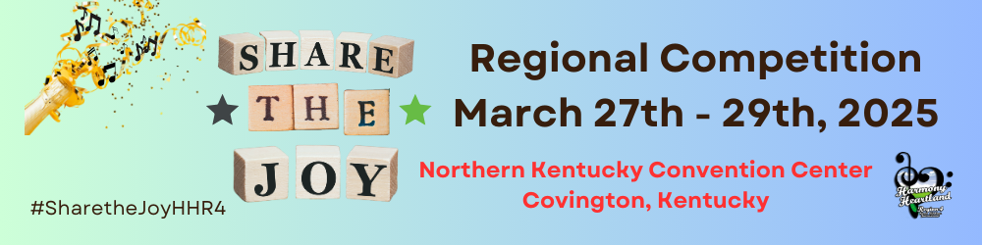2025 Regional Convention & Competition Kick-off

Your Convention Team is excited for our 2025 Regional Competition and Convention in just over 3 months. We began planning in May and meet regularly to keep things rolling as we want everyone to Share the Joy of this wonderful artform we call Barbershop Music.

The Contest website goes live Friday, December 13, 2024, which falls in line with Sweet Adelines Registration Opening for Region 4.

A Zoom Q&A Session will be held on Sunday, January 5, 2025, at 7pm EST. If you have questions about the website, please add this meeting to your calendar. We will send the link out to everyone a few days prior to the session. We will record the session for those not able to attend live.

IMPORTANT 2025 COMPETITION DEADLINES
January 27 – International/Regional Registration closes
February 3 – Draw for Order of Appearance
February 11 – Late Registration closes (late fee assessed)
February 21 – Competitor AET Confirmation List Due
February 28 – Housing Block closes
March 1 – Big Screen Ads, Big Screen Shout Outs, HUB applications, Volunteer applications Due

OTHER KEY INFORMATION

HOUSING REGISTRATION – This year, each Chorus Registration Chair will receive a specific link to their Choruses housing sub-block of rooms.
- Each sub-block is assigned specific numbers and types of rooms within the designated hotel (Marriott or Embassy Suites). A detailed breakdown will be included in the email, along with the link.
- Every Registration Chair is responsible for securing rooms for their chorus members within the sub-block. Whether this is done by a single person, or by each room captain/individual member, is up to the Registration Chair. However, please note that there are a limited number of rooms within each sub-block, so coordination by the Registration Chair is recommended, regardless of who makes the reservations.
- All competing quartets should work with their home chorus to secure their room(s) within the designated sub-block.
- Those members (CAL/MAL/etc.) that do not have a home chorus will be able to contact Lura Nightlinger for a housing link.
NOTE: Any competing chorus or quartet member that chooses not to stay at a hotel via the room block will be assessed a $50 no stay fee.

THE PATTERN – We will not be using the ever-popular freight elevator again this year. Members will leave their designated warm-up room and use the escalator to make their way to the pre-stage area. However, we recognize this may not be the case for all our competitors, so we will do our best to accommodate those with special situations. The Director/President will work with the Contest Chairs for any special needs in advance of the contest and then finalize at the contest check-in/briefing Thursday March 27th.

Chorus members personal items - It is recommended that choruses use a wagon for individual members to collect and transport personal items that have been placed in easily identifiable individual member bags. The wagon will travel through the pattern with the Chorus. There will be a designated area behind the stage to park the wagon while performing. The region does not provide wagons/travel bags or individual member bags.

THE STAGE – We will be using the same configuration and set up as last year with no raised stage.

SERVICE ANIMAL - This year we will have a couple of service dogs participating in our regional Contest/Convention. Gem City Chorus member Aleeha and her service dog, Dillon, answered a few questions about blindness etiquette. Please review the short video of Deb Bringman’s interview with Aleeha.

COVID PROTOCOLS - As the national COVID protocols have lessened, we will not require masks at this time. It is a personal decision to wear one if you want.

HOSPITALITY ROOMS – The region will not be hosting an afterglow. We will provide a list of Chorus Hospitality Rooms that attendees can visit on Saturday evening. Choruses must submit their Hospitality Room information to Lura Nightlinger no later than March 1st to be included. We will post this list on the website as well as on the Big Screen.

THE HUB - We will have the HUB. If you know of any vendors that would like to set up a table/booth, an application will need to be submitted. The deadline to apply is March 1st. All details can be found on the contest website.

ALL EVENT TICKETS (Name Badge) – All region 4 members and non-Region 4 Quartet members competing will need to have a name badge (AET). The AET form will be completed by the Chorus leadership. These will be packaged and handed out to the Chorus Director/President at the Contest briefing. Any CAL/MAL member can order/purchase their AET via the website. They can be picked up at the Registration Table located in the HUB.

SINGLE EVENT TICKETS - Single Event Tickets for family/friends coming to see a single contest (Quartet or Chorus) can purchase their ticket at the Registration Table in the HUB that day. Pricing and additional information is listed on the website.

Your Convention/Competition Team: Natalie Allen, Donna Ebelhar, Jamie Kamin, Carolyn Kolarik, Beverly Miller, Lura Nightlinger, Liz Sabo Johnson

