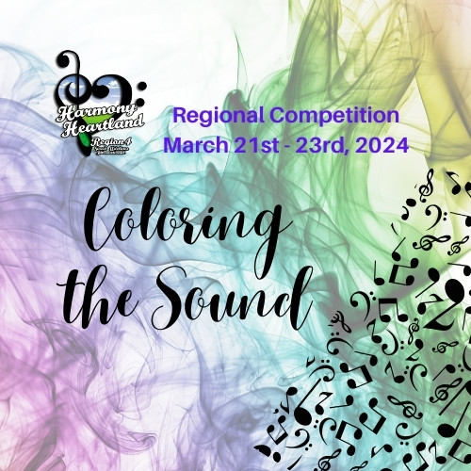
Harmony Heartland
Region 4 HUB

Thursday, March 21 - 6pm – 10pm

Friday, March 22 - 9pm – 9pm

Saturday, March 23 - 9am – 3pm

HUB EXHIBITORS
My Sister Sings
Beads n More
Metro Nashville Chorus
Pride of Kentucky Chorus
Tenacious Quartet
QC Club
Rising Stars of Region 4
Region Registration/Lost and Found

